Exercise 2‑1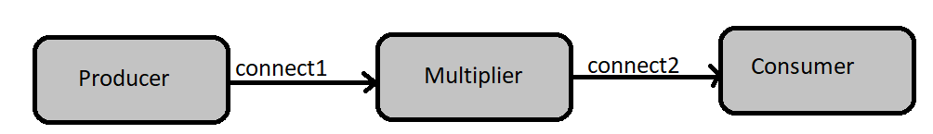

Multiplier:



Consumer:



RunMultiplier:



## Output:

next: 1

next: 4

2

next: 8

3

next: 12

4

next: 16

5

next: 20

6

next: 24

7

next: 28

8

next: 32

0

Finished

# **Exercise 2-2**

## GenerateSetsOfThree:



## ListToStream:



## CreateSetsOfEight:



## Output:

Eight Object is [1, 2, 3, 4, 5, 6, 7, 8]

Eight Object is [9, 10, 11, 12, 13, 14, 15, 16]

Eight Object is [17, 18, 19, 20, 21, 22, 23, 24]

Finished

## Answers:

1. In GenerateSetsOfEight change

To



2. One can parametrise the end value of “I” in above mentioned for loop.

3. The program doesn’t terminate, as it never receives a list of [-1,-1,-1] , due to “leftover” integers from lists of threes.